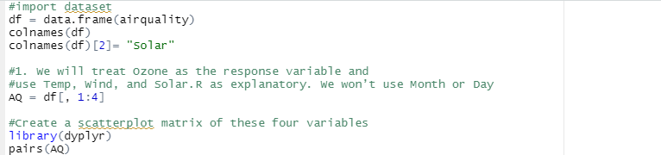

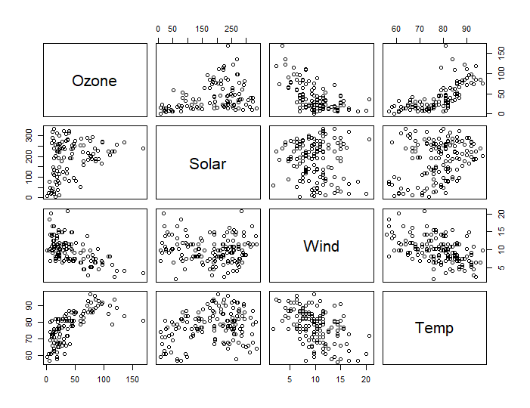

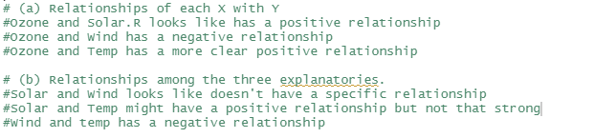

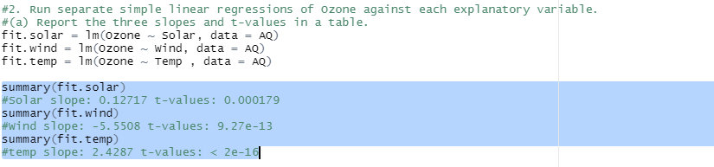



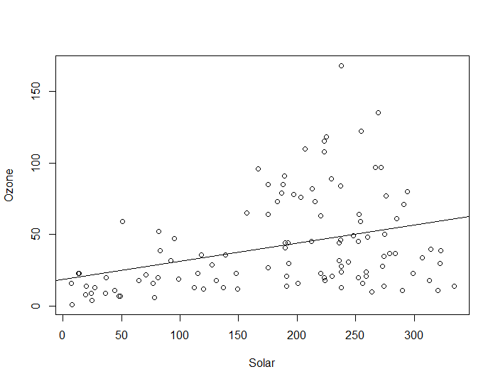

# The line looks okay in that as solar increases, Ozone also increases.



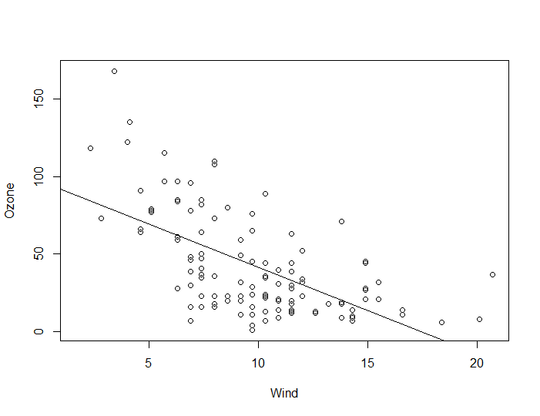

# The line looks okay but there are some variances.



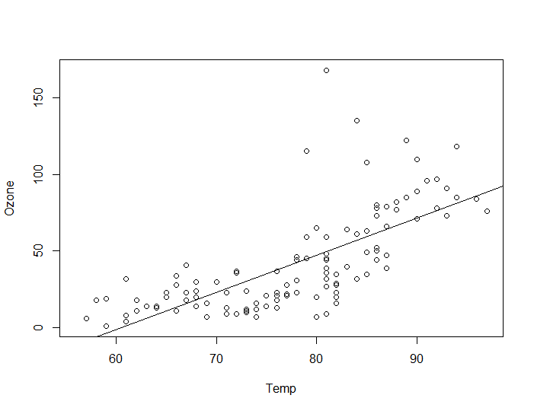

# This line fits well compare to other lines. The line shows the general trend well.